Boer Goat Breeders’  Association of Australia Ltd  ACN 067 659 081 ABN 840 676 590 81  C/- ABRI  University of New England  Armidale NSW 2351  Tel: 02 6773 5177 Fax: 02 6772 1943  Email: boergoat@abri.une.edu.au  Web: www.australianboergoat.com.au | 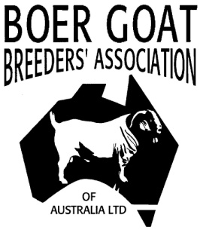 | Executive Officer: John Thomas  Tel: 02 6773 3126  Email: john.thomas@abri.une.edu.au
Boer Goats – ‘Meating’ the Market
Vendor’s Declaration: At the time of Sale ……………………………………… (state name) as the vendor agree that the Kids listed above MAY / MAYNOT be registered.

Date of Sale: …………………………
DOE WITH PROGENY SOLD AT FOOT AGREEMENT FORM
Sale of Doe with Progeny at foot (kids that are 3 months and under):
Please complete details below. This form must be signed by the vendor at the time of sale. The new
owner is responsible for payment of registration fees. No transfer fees apply to the kids at foot, but do apply to the doe. This form must be sent together with a completed registration application by the new owner for processing at ABRI.
Vendor Stud Name:
………………………………………………………………..
Vendor Stud Prefix:
………………………………
Purchaser Stud Name:
………………………………………………………………..
Purchaser Stud Prefix:
………………………………
Doe (Dam) ID: ………………………… Buck (Sire) ID: …………………………
SOLD WITH THE FOLLOWING KIDS AT FOOT
1.
Kid ID:
………………………
DOB:
………………………
SEX:
M / F
2.
Kid ID:
………………………
DOB:
………………………
SEX:
M / F
3.
Kid ID:
………………………
DOB:
………………………
SEX:
M / F
4.
Kid ID:
………………………
DOB:
………………………
SEX:
M / F
Vendor’s Signature:

………………………………………………………………..

