Boer Goat Breeders’  Association of Australia Ltd  ACN 067 659 081 ABN 840 676 590 81  C/- ABRI  University of New England  Armidale NSW 2351  Tel: 02 6773 5177 Fax: 02 6772 1943  Email: boergoat@abri.une.edu.au  Web: www.australianboergoat.com.au |  | 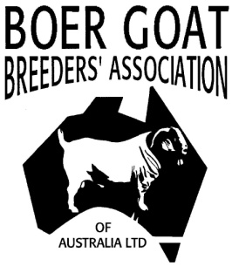
Boer Goats – ‘Meating’ the Market

SALE AGREEMENT FORM FOR RETAINED SEMEN AND EMBRYOS

This document is to be used as an agreement between the Owner and the Purchaser for the
purpose of retained genetic material ONLY.
The BGBAA cannot become involved in personal disputes.

Completed Forms are to be sent to Registrar at the time of purchase by owner/breeder

DATE: ________________

I___________________________________, of Stud name _____________ have SOLD the following buck/ doe ______________________________ (registration number)
to:
Name__________________________________________________ of,
Stud name ____________________________ herd prefix___________

Checklist (At the time of Collection)
Is the Animal currently ACTIVE in BGBAA Herd book (at time of collection) Yes No
Is the owner currently a financial member of BGBAA (at time of collection) Yes No

Semen information – BUCK ID –

I…………………………………………………………………… (Current breeder/ owner) retain the rights to keep semen straws or pellets from the above buck, that were collected prior to the animal being sold.

- Number of Straws retained
- Number of Pellets retained

Embryo Information – DOE ID

I…………………………………………………………………… (Current breeder/ owner) retain the rights to keep any embryos produced from the above doe that were collected prior to the animal being sold.

Other Stipulations:

Signature of Breeder/Owner: Date: / / 20

Signature of Purchaser Date: / / 20

